**Enterprise Resource Planning**

**Training User Manual**

**VERSION 12.0.0**

**INVENTORY**

**Index**

|  |  |
| --- | --- |
| **About** | **Page No.** |
| * Direct Issue Entry | **03** |
| * Issue For Production | **04** |
| * Damage Entry | **05** |
| * Create GRN | **06** |
| * IM To GL Transfer | **10** |
|  |  |

* Direct Issue Entry

|  |  |
| --- | --- |
| **Step 1** | Main Menu (Home Icon) **> Inventory Management >**  Direct Issue Entry |
| **Step 2** | Define Store no, choose Item Code to Issue and write Qty, Department, Rate etc. |
| **Step 3** | Click **Add** and then Click **Confirm** to confirm Issue |
| **Result** | A new **Issue** will be created. |

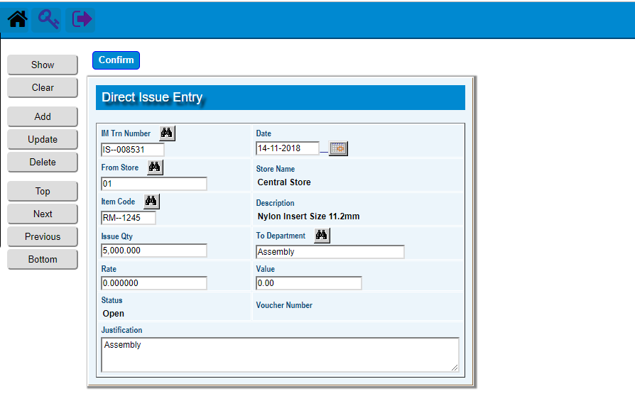

* Issue For Production

|  |  |
| --- | --- |
| **Step 1** | Main Menu (Home Icon) **> Inventory Management >**  Issue For Production |
| **Step 2** | choose Item Code to Issue and write Qty, From Store , To Store etc. |
| **Step 3** | Click **Add** and then Click **Confirm** to confirm Issue |
| **Result** | A new **Issue For Production** will be created. |

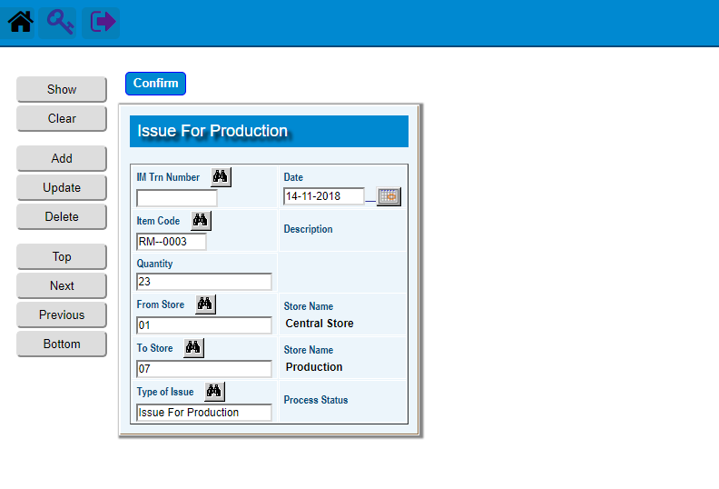

* Damage Entry

|  |  |
| --- | --- |
| **Step 1** | Main Menu (Home Icon) **> Inventory Management >**  Damage Entry |
| **Step 2** | Define Store no, choose Item Code to Issue and write Qty, Department etc. |
| **Step 3** | Click **Add** |
| **Result** | A new **Damage Entry** will be created. |

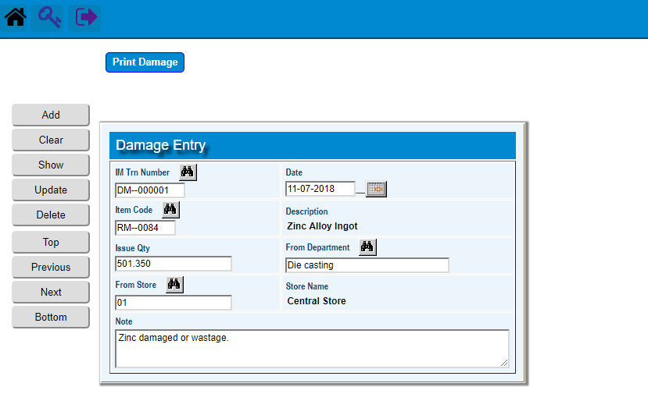

* Create GRN

|  |  |
| --- | --- |
| **Step 1** | Main Menu (Home Icon) **> Inventory Management >** Create GRN |
| **Step 2** | Choose A Purchase Order No to Create GRN |
| **Step 3** | Click **Create GRN** button |
| **Result** | GRN will be created against the PO. |

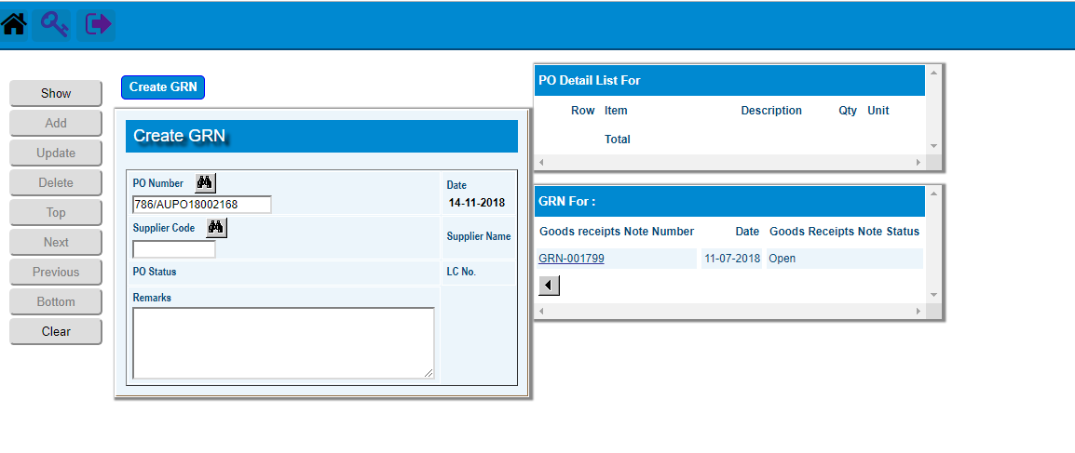

** Pick the created GRN to go GRN Header

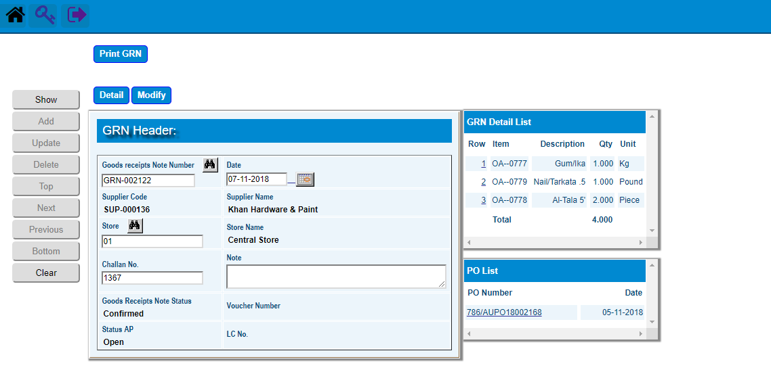

**) Click **Detail** for GRN detail and then Click **Return** to return GRN Header

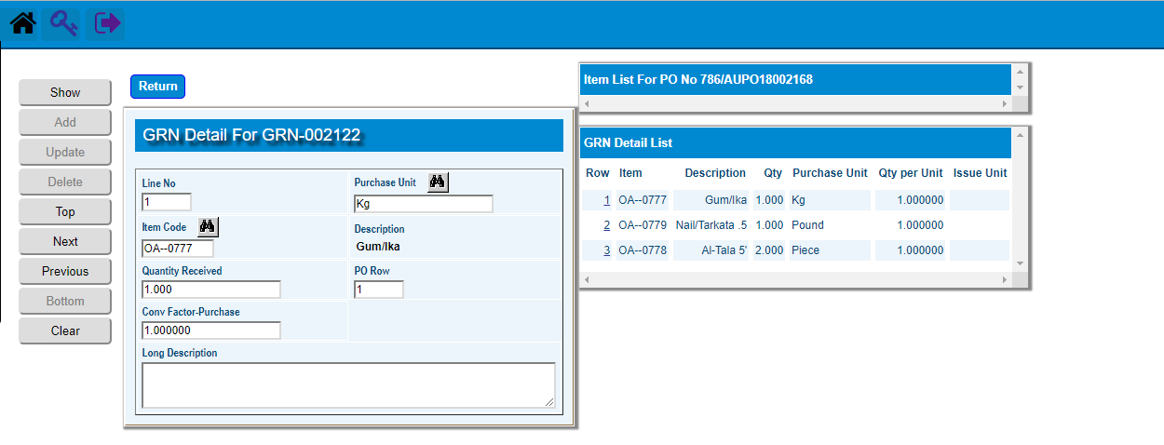

**\*\*)** Click **Confirm** to Confirmthe GRN

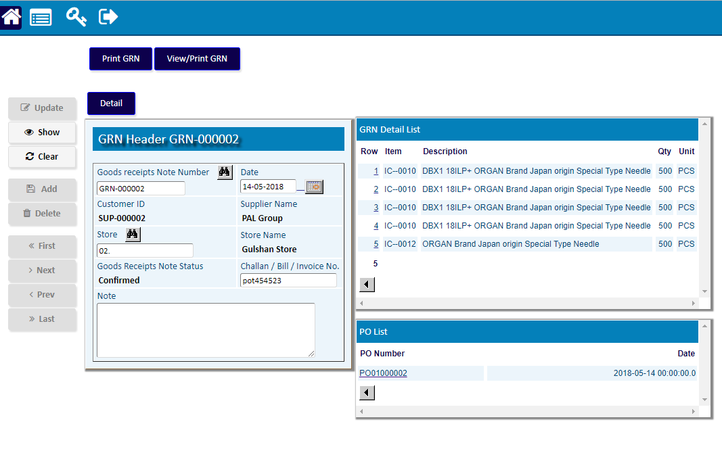

* IM To GL Transfer

|  |  |
| --- | --- |
| **Step 1** | Main Menu (Home Icon) **> Inventory Management >**  IM To GL Transfer |
| **Step 2** | Define From Date, To Date, From Voucher, To Voucher & Posting Date |
| **Step 3** | Click **Final Run** |
| **Result** | The Desired Issues will be transferred to GL. |

